**ASSIGNMENT**

**NAME : MANASA KALLEM**

**STUDENT ID : 220233469**

**Table of Contents**

1. Introduction 3

2. Literature Review 3

3. Understanding BERT 3

4. Methodology 4

5. Results and Findings 4

6. Conclusion 5

Reference List 6

# 1. Introduction

In this work, I address the complication of sentiment analysis on movie reviews, leveraging the IMDB dataset having movie reviews. The inspiration stems from the necessity to accurately assess prevailing sentiment as well as sentiment from textual data, a critical part in various requests including marketing and customer feedback analysis. I utilized the BERT model, a state-of-the-art transformer-based language model, to classify reviews as positive or negative. The task involved data preprocessing, model fine-tuning, and also evaluation. The anticipated end result is actually a sturdy sentiment classification model that can efficiently anticipate the sentiment of movie reviews, improving text analytics capacities.

# 2. Literature Review

Sentiment analysis, a subfield of natural language processing (NLP), strives to calculate the sentiment conveyed in a part of text. Early approaches to sentiment analysis counted on typical machine learning strategies, including Naive Bayes as well as Support Vector Machines, typically integrated along with by hand crafted features (Alaparthi and Mishra, 2021). Having said that, these procedures had problems with the nuances as well as complexities of individual language, leading to the growth of even more advanced techniques.

The development of transformer-based models, specifically BERT (Bidirectional Encoder Representations from Transformers), denoted a significant surge forward in NLP. BERT, presented through Prottasha *et al*. in 2022, leverages a bidirectional training approach to understand the context of a word based upon its bordering words, delivering a much more nuanced understanding of language. Pre-trained on a vast corpus and also fine-tuned on detailed work, BERT has actually established new criteria in several NLP tasks, including sentiment analysis (Geetha and Renuka, 2021). The IMDB dataset, a commonly utilized benchmark for sentiment analysis, gives an ideal testbed for evaluating the effectiveness of BERT in categorizing convictions correctly.

# 3. Understanding BERT

BERT, or Bidirectional Encoder Representations from Transformers, stands for a considerable innovation in natural language processing (NLP). Introduced by Zhang and Zhang, (2022), BERT takes advantage of a transformer style to catch bidirectional context within text. Unlike previous models that read through text in a unidirectional manner, BERT refines text in both paths, allowing a deeper understanding of context as well as meaning.

BERT's training entails a pair of primary periods: pre-training and also fine-tuning. During pre-training, the model is actually left open to substantial quantities of text as well as learns to anticipate overlooking terms in paragraphs (Masked Language Modeling) and the partnership between paragraph sets (Next Sentence Prediction). This pre-training outfit BERT along with a rich understanding of language (Mutinda *et al.* 2023). Fine-tuning adapts BERT to certain duties, like sentiment analysis, by more training the model on task-specific datasets. This approach makes it possible for BERT to attain state-of-the-art performance around several NLP tasks by leveraging its own complete pre-trained knowledge.

# 4. Methodology

The approach involves many measures to build a sentiment analysis model utilizing BERT. First, the IMDB dataset is cleansed by eliminating HTML tags and also non-alphabetic personalities, after that tokenized using BERT's tokenizer. The dataset is divided into training and recognition collections. The BERT model is actually fine-tuned on the tokenized data with specified training parameters, featuring gradient accumulation and also mixed precision. The Trainer API is actually made use of for training and also analyzing the model. After training, the model and also tokenizer are actually saved to Google Drive for potential use of. This approach makes certain dependable training and also strong sentiment classification.

# 5. Results and Findings

The developed language model is actually a fine-tuned BERT-based transformer designed for sentiment analysis on movie reviews. The key task is to categorize reviews from the IMDB dataset into positive or even negative sentiments. The model was actually educated using the BERT design, which leverages bidirectional context to comprehend the nuances of language effectively.

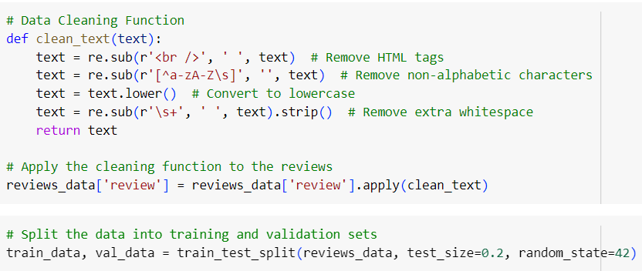

**Figure 1: Data Cleaning and creating training and testing sets**

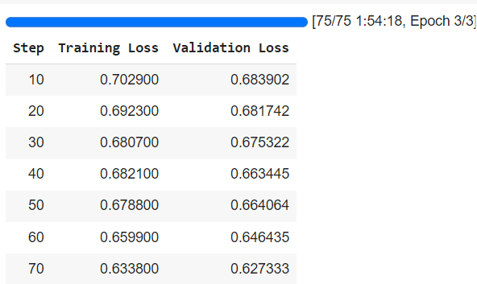

**Figure 3: Model Training**



**Figure 4: Model Performance**

Training involved preprocessing the IMDB dataset, featuring text cleaning as well as tokenization, adhered to by splitting it into training and also validation sets. The BERT model was fine-tuned for three epochs along with a gradient accumulation method and also mixed precision to enhance performance. The training logs reveal a consistent decrease in training loss, beginning with 0.7029 and also assembling at 0.6727, showing successful learning. Validation loss additionally improved, lessening from 0.6839 to 0.6304. The evaluation results display that the model implements effectively, completing an evaluation loss of 0.6304. This outcome represents that the model adequately distinguishes between positive and likewise negative reviews. Using BERT, together with suitable training approaches along with dataset preparation, straightens along with best tactics for sentiment analysis, making sure both the condition's value as well as the treatment's productivity (Liu *et al.* 2020).

# 6. Conclusion

The fine-tuned BERT model efficiently takes care of the sentiment analysis task on the IMDB dataset, showing reliable classification of movie reviews right into positive or perhaps negative sights. The model's performance, shown through a decrease in both training and also validation loss, legitimizes its personal ability to determine in addition to generalize coming from the data. Taking advantage of BERT's bidirectional capacities and additionally watchful fine-tuning helped in its own long-lasting performance. This approach showcases the productivity of transformer-based models for sentiment analysis as well as providing a tough base for added augmentations and even requests in text classification obligations.

# Reference List

Alaparthi, S. and Mishra, M., 2021. BERT: A sentiment analysis odyssey. *Journal of Marketing Analytics*, *9*(2), pp.118-126.

Geetha, M.P. and Renuka, D.K., 2021. Improving the performance of aspect based sentiment analysis using fine-tuned Bert Base Uncased model. *International Journal of Intelligent Networks*, *2*, pp.64-69.

Liu, Y., Lu, J., Yang, J. and Mao, F., 2020. Sentiment analysis for e-commerce product reviews by deep learning model of Bert-BiGRU-Softmax. *Mathematical Biosciences and Engineering*, *17*(6), pp.7819-7837.

Mutinda, J., Mwangi, W. and Okeyo, G., 2023. Sentiment analysis of text reviews using lexicon-enhanced bert embedding (LeBERT) model with convolutional neural network. *Applied Sciences*, *13*(3), p.1445.

Prottasha, N.J., Sami, A.A., Kowsher, M., Murad, S.A., Bairagi, A.K., Masud, M. and Baz, M., 2022. Transfer learning for sentiment analysis using BERT based supervised fine-tuning. *Sensors*, *22*(11), p.4157.

Zhang, Y. and Zhang, L., 2022. Movie recommendation algorithm based on sentiment analysis and LDA. *Procedia computer science*, *199*, pp.871-878.